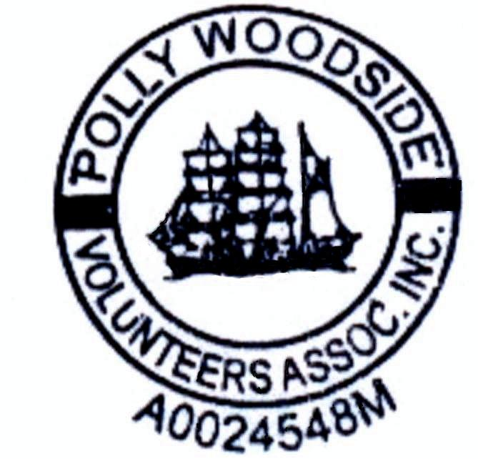

Welcome to the POLLY WOODSIDE and our Melbourne Maritime Museum. Although the Melbourne Maritime Museum was closed by the National Trust (Victoria) in 2006, we welcome your support and assistance in our continuing efforts to maintain POLLY WOODSIDE.

Membership of the POLLY WOODSIDE VOLUNTEERS’ ASSOCIATION INC. is available by nomination and ratification by the Committee. On acceptance of your application with the Annual Subscription of $20 per family, a membership card and the latest issue of or newsletter WAVE will be mailed to you.

Membership entitles you to:

- Mailing of each issue of ‘WAVE’ (quarterly)

- Invitations to Social Club functions

- Voting at General Meetings

See the Contact Us page if you have any queries. Please post this form to the Treasurer, see Contact Us page for the address.
Cheques to be made payable to: POLLY WOODSIDE VOLUNTEERS’ ASSOCIATION INC.

-------------------------------------------------------------------------------------------------------------------------------

APPLICATION FORM DATE:……………….............

NAME…………………………………………… Phone (Home)………………….………..……..

ADDRESS……………………………………… (Mobile)…………………………….………..…..

…………………………………………...........… (Email)…………………………….....……....….

………………………………………...........……

AREAS OF INTEREST: [ ] SHIP RESTORATION & MAINTENANCE

[ ] STEAM ENTHUSIAST

[ ] GENERAL HANDYPERSON

[ ] OTHER INTERESTS: PLEASE SPECIFY

PROPOSED BY: ……………………….. SIGNATURE: …………………………………

